**Wednesday, September 7th, 2022**

|  |  |
| --- | --- |
| **Meeting called to order:** | **Mike Smith-Treasurer** |

**OFFICER REPORTS:**

**Secretary’s Report**

* August minutes approved

**Motion to approve-Stephanie Harris; Second-Jill Shawhan**

**All in favor-Approved**

**Treasurer’s Report**

* August Financials

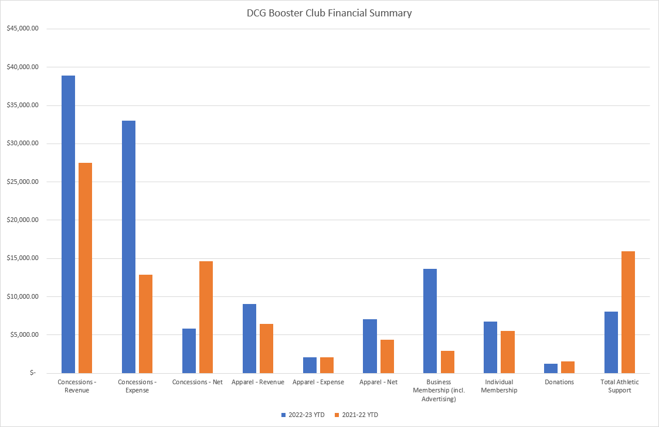

**Motion to approve-Lisa Green; Second-Stephanie Harris**

**All in favor-Approved**

**VP Report**

* 86 family Membership
* 12 Sponsors
* 90 kids signed up for Jr. Stampede

**Homecoming Stencils**

* 3 Team Leaders:
  + Nick Reggio
  + Danielle Carlson and Laura
  + Erica Davis and Nikki Jarchow

3 Stencils and 4 cases of paint have been purchased

Team Leaders will manage the stencil and paint

**Trivia Night**

Destination Grill will sponsor this event

Will provide: Soda, water, and pizza along with a room

Date-To be determined. Looking into the spring

Grimes Community Foundation Gala was a great success.

Booster Club to send a thank you note to donors

**Motion to approve-Mike Smith; Second-Lisa green**

**All in favor-Approved**

**Scheduling Report**

No concessions or Spirt Shed will be open during homecoming games

Increased the number of concessions stand volunteers for football in order to have three windows open.

**Concession Purchasing Report**

* Alison recognized Leslie for doing such a great job with purchasing.
* Pepsi ordered a new cooler for Oakview.
* Request to have the refrigerator removed
* Discussed outdoor concessions at Oakview and lack of storage options. Brent advised no plans at this time. Alison requesting to be involved in the discussion
* Condiment trays received
* Popcorn machine received
* Smoothie King has approached DCG to sale smoothies at events.
* Concessions sold over 300 hamburgers at the last football game.
* New food idea: Cool Ranch Doritos (like walking tacos)
  + Chicken
  + Lettuce
  + Shredded Cheese
  + Drizzle ranch on top
* Proposed to purchase napkin and silverware dispensers. Allison will get pricing and report back

**Merchandise Report**

* Shed has been stocked with new apparel
* Ordered additional winter hats

**Communications Report**

October Monthly Mustang Newsletter updates

Boo-Tique

Basketball Tournament registration is open

Link for streaming

Sponsorships for each game

**Technology Report-**

Looking for a commentator for Tuesday nights volleyball game.

May also need someone for Friday nights football game.

Brent will look into some help

Streaming is going Well

New camera in huddle

For the 3 smaller camera’s purchased, we need a stronger WIFI.

Recommendation to purchase Mesh routing system (Signal Booster) $430.00.

**Motion to approve-Mike Smith; Second-Paige Fenn**

**All in favor-Approved**

**Athletic Director Update/Requests:**

Autograph Footballs $150

JV Girls Uniforms $4,320

Basketballs 12 girls/12 boys $1,584

Girls Wrestling

20 Head Gear $640

17 Warm Up’s $1,700

32 Uniforms $1,950

**Total $10,344**

**Motion to approve-Paige Hart; Second-Dani Versluis**

**All in favor-Approved**

**Business**

* Basketball Tournament
  + Registration is open. 9 boy teams signed up
  + Looking at water bottles for prizes. Danielle will order samples
* 2023 Golf outing
  + Looking into a venue. TCI, Jester and Beaver Creek Golf Course
* Homecoming Parade
  + Thursday, September 15th
  + Line up at 5:45 in Dallas Center and starts at 6:15
  + Paige will purchase candy
  + Need to locate Booster Club Banner
  + Danielle will order Booster Club tee-shirts
* Homecoming Tailgate from 4:45 pm to 7:00 pm
  + Brent advised school has tables but no chairs
  + Fareway donating Food
  + DJ will be playing
  + Bags will be set up
  + Booster Club members attend to meet and greet.
  + Will have QR codes to purchase memberships and Jr. Stampede
* Boo-Tique
  + October 9th from 4:00 pm to 7:00 pm
  + 15 Vendors
  + Presenting Sponsor: Photo Booth
  + Serve: Chili, cinnamon rolls, baked potatoes and pumpkin bars.
* Cake Auction
  + February 10th against Pella
* Scholarship Committee
  + Mike Smith, Danielle Carlson, Jill Shawhan, Alison Seidl and Lisa Green will work on program criteria
* JR Stampede
  + 90 Jr members
  + Shirts, autograph books, pens, lanyard, and postcards
  + Dates:
    - October 6th-Volleyball
    - October 10th-X-Country in Dallas Center
    - October 14th-Football. Could we have seating in the end-zone?
  + Will need volunteers

**Dates to Remember**

* Next Booster Club Meeting: Wednesday, October 5th, 2022, at 6pm. High School Media Center
* Homecoming-September 16th, 2022
* October 6th-Pink Out